

**CSC204-Database Systems Project Report**

**Learning Management System**

**Submitted To**

**Engr. Zartasha Baloch**

**Submitted By**

**Muhammad Hunain Ismail (20BSCS043)**

**Muhammad Taimoor Khan (20BSCS045)**

**Haiqa Nayab (20BSCS024)**

***Department of Computer System Engineering,***

***Mehran University of Engineering & Technology.***

**Overview:**

A learning management system (LMS) is a software application for the administration, documentation, tracking, reporting, automation, and delivery of educational courses, training programs, or learning and development programs.

**Problem Statement:**

The problem statement of this Project is as follows:

1. The e-learning network works, which makes it capable of being instantly updated, stored, retrieved, distributed and allows to share instruction or information.
2. It is delivered to the end user through the use of computers using standard Internet technology.
3. It focuses on the broader vision of learning that goes beyond traditional training paradigms.
4. There are 4 Panels: Admin, Moderator, Teachers & Students
5. To store, update and delete the data of Student, Teacher & Staff members of an Institution.
6. Admin can add, edit and delete Staff members, Teachers and Students.
7. Moderator can add & edit new Batch of Students.
8. Teacher can assign Tasks to Students according to their Batches.
9. Teacher can assign Tasks to Students separately also.
10. Student can view their own data.
11. Students can view the Tasks assigned by different Teachers.
12. Students can upload their completed Tasks.

**Design:**

**Admin Table Structure:**

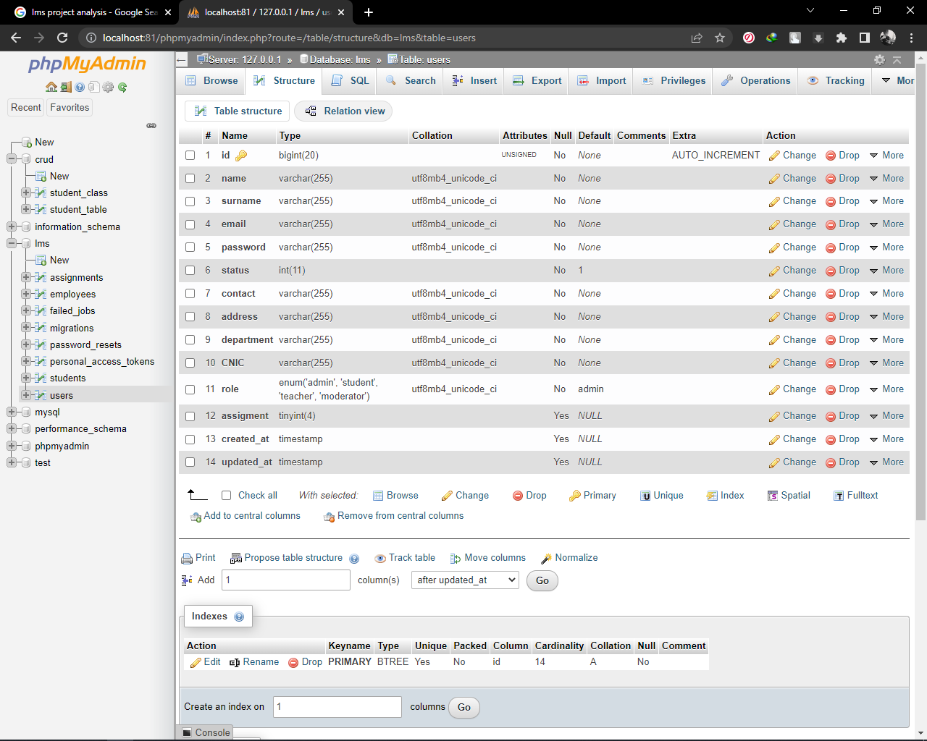

**Student Table Structure:**

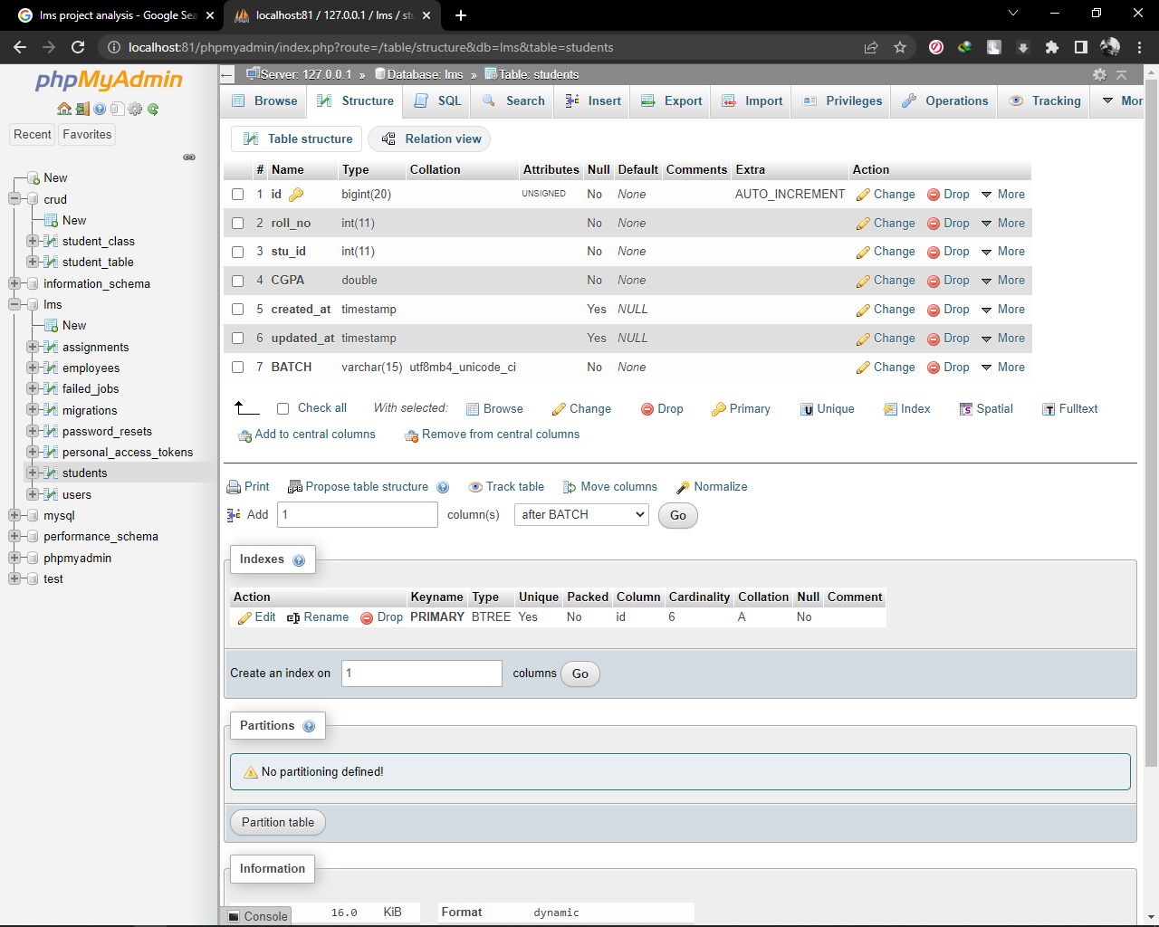

**Employee Table Structure:**

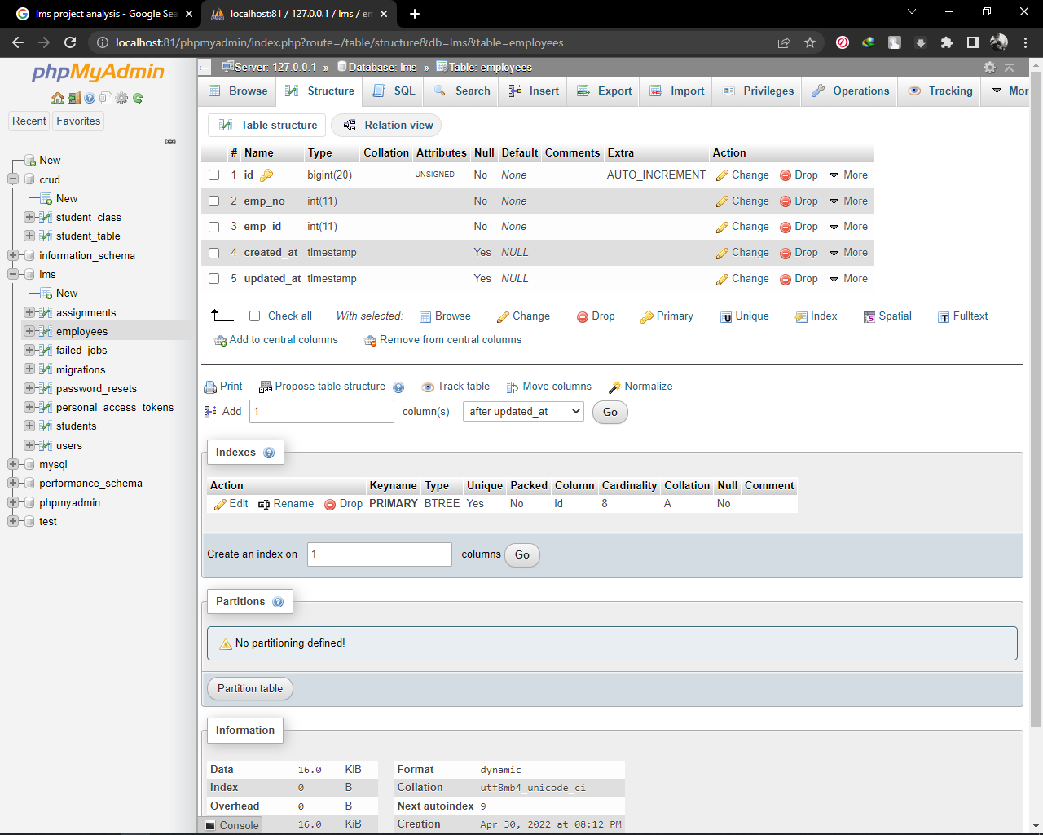

**Assignment Table Structure:**

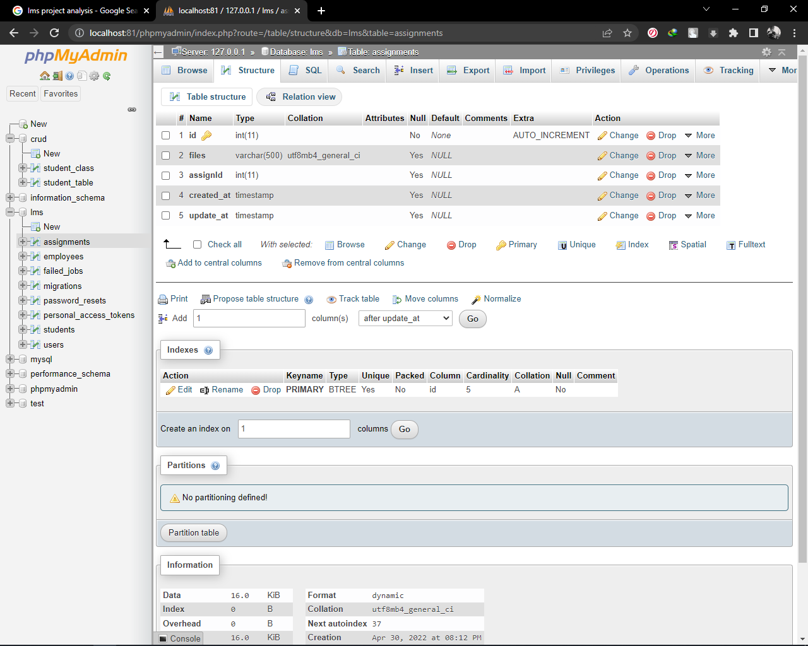

**Implementation:**

**Creating Tables/Panels:**

CREATE TABLE `users` (

`id` bigint(20) UNSIGNED NOT NULL,

`name` varchar(255) COLLATE utf8mb4_unicode_ci NOT NULL,

`surname` varchar(255) COLLATE utf8mb4_unicode_ci NOT NULL,

`email` varchar(255) COLLATE utf8mb4_unicode_ci NOT NULL,

`password` varchar(255) COLLATE utf8mb4_unicode_ci NOT NULL,

`status` int(11) NOT NULL DEFAULT 1,

`contact` varchar(255) COLLATE utf8mb4_unicode_ci NOT NULL,

`address` varchar(255) COLLATE utf8mb4_unicode_ci NOT NULL,

`department` varchar(255) COLLATE utf8mb4_unicode_ci NOT NULL,

`CNIC` varchar(255) COLLATE utf8mb4_unicode_ci NOT NULL,

`role` enum('admin','student','teacher','moderator') COLLATE utf8mb4_unicode_ci NOT NULL DEFAULT 'admin',

`assigment` tinyint(4) DEFAULT NULL,

`created_at` timestamp NULL DEFAULT NULL,

`updated_at` timestamp NULL DEFAULT NULL

)

CREATE TABLE `students` (

`id` bigint(20) UNSIGNED NOT NULL,

`roll_no` int(11) NOT NULL,

`stu_id` int(11) NOT NULL,

`CGPA` double NOT NULL,

`created_at` timestamp NULL DEFAULT NULL,

`updated_at` timestamp NULL DEFAULT NULL,

`BATCH` varchar(15) COLLATE utf8mb4_unicode_ci NOT NULL

)

CREATE TABLE `employees` (

`id` bigint(20) UNSIGNED NOT NULL,

`emp_no` int(11) NOT NULL,

`emp_id` int(11) NOT NULL,

`created_at` timestamp NULL DEFAULT NULL,

`updated_at` timestamp NULL DEFAULT NULL

)

CREATE TABLE `assignments` (

`id` int(11) NOT NULL,

`files` varchar(500) DEFAULT NULL,

`assignId` int(11) DEFAULT NULL,

`created_at` timestamp NULL DEFAULT NULL,

`update_at` timestamp NULL DEFAULT NULL

)

**Data Manipulation into Created Tables/Panels:**

INSERT INTO `users` (`id`, `name`, `surname`, `email`, `password`, `status`, `contact`, `address`, `department`, `CNIC`, `role`, `assigment`, `created_at`, `updated_at`)

VALUES

(19, 'hammad', 'Memon', 'ham@gmail.com', '123456', 1, '984615320', 'LAtifabad no 06', 'CS', '4130283261720', 'moderator', 0, '2022-04-09 07:24:00', '2022-04-09 07:24:00'),

(20, 'Muhammad jab', 'Memon', 'j@gmail.com', '123456', 1, '568945132', 'latifabad', 'CS', '4130283267891', 'moderator', 0, '2022-04-09 11:05:02', '2022-04-09 11:05:02'),

(21, 'Muhammad Taimoor', 'Khan', 'taimoor@gmail.com', '123456', 1, '5120561230', 'Latifabad # 06', 'CS', '4130283267102', 'moderator', 0, '2022-04-09 16:08:25', '2022-04-09 16:08:25'),

(22, 'Teacher', 'Memon', 'hammad@gmail.com', '123456', 1, '52520', 'Latifabad # 06', 'CS', '4130283267104', 'teacher', 0, '2022-04-09 16:35:07', '2022-04-09 16:35:07'),

(23, 'Muhammad Hassam', 'Memon', 'hassan@gmail.com', '12345', 1, '48651320', 'Latifabad no 8', 'CS', '4130283267106', 'teacher', 0, '2022-04-09 16:39:25', '2022-04-09 16:39:25'),

(24, 'Muhammad ismail', 'Memon', 'ismail@gmail.com', '123456', 1, '03183051200', 'LAtifabad # 06', 'CS', '4030283267101', 'admin', 0, NULL, NULL),

(26, 'hunain', 'memon', 'ht@gmail.com', '123456', 1, '465120', 'sadfghbm,', 'sdfg', '4130282367108', 'teacher', 0, '2022-04-11 15:08:31', '2022-04-11 15:08:31'),

(27, 'Haiqa Nayab', 'Shaikh', 'haiqa@gmail.com', '1234567', 1, '542', 'Latifabad #-8', 'CS', '4130283267103', 'teacher', NULL, '2022-04-18 06:15:21', '2022-04-18 06:15:21'),

INSERT INTO `students` (`id`, `roll_no`, `stu_id`, `CGPA`, `created_at`, `updated_at`, `BATCH`) VALUES

(7, 27, 34, 3, '2022-04-19 02:03:36', '2022-04-19 02:03:36', '20BATCH'),

(8, 25, 35, 2, '2022-04-19 13:00:03', '2022-04-19 13:00:03', '21BATCH'),

(9, 26, 36, 5, '2022-04-19 13:01:01', '2022-04-19 13:01:01', '19BATCH'),

(10, 52, 37, 3, '2022-04-19 13:02:13', '2022-04-19 13:02:13', '18BATCH'),

(11, 8956213, 38, 3, '2022-04-19 13:05:24', '2022-04-19 13:05:24', '20BATCH'),

(12, 38, 39, 3, '2022-04-20 01:01:47', '2022-04-20 01:01:47', '20BATCH');

INSERT INTO `assignments` (`id`, `files`, `assignId`, `created_at`, `update_at`)

VALUES

(32, 'docs/Z2H0Yum707k1m1wuZ0H07cPIcjuAXHIcAS9bTaoc.pdf', 34, NULL, NULL),

(33, 'docs/Z2H0Yum707k1m1wuZ0H07cPIcjuAXHIcAS9bTaoc.pdf', 38, NULL, NULL),

(34, 'docs/05UEGLavaMhcqaQjDkDke2J0LK0DOdmNRBEaMsKU.pdf', 34, NULL, NULL),

(35, 'docs/05UEGLavaMhcqaQjDkDke2J0LK0DOdmNRBEaMsKU.pdf', 38, NULL, NULL),

(36, 'docs/05UEGLavaMhcqaQjDkDke2J0LK0DOdmNRBEaMsKU.pdf', 39, NULL, NULL);

INSERT INTO `employees` (`id`, `emp_no`, `emp_id`, `created_at`, `updated_at`)

VALUES

(1, 74512, 18, '2022-04-09 07:22:46', '2022-04-09 07:22:46'),

(2, 5982, 19, '2022-04-09 07:24:00', '2022-04-09 07:24:00'),

(3, 3251, 20, '2022-04-09 11:05:02', '2022-04-09 11:05:02'),

(4, 625, 21, '2022-04-09 16:08:25', '2022-04-09 16:08:25'),

(5, 1222, 22, '2022-04-09 16:35:07', '2022-04-09 16:35:07'),

(6, 651, 23, '2022-04-09 16:39:25', '2022-04-09 16:39:25'),

(7, 515562, 26, '2022-04-11 15:08:31', '2022-04-11 15:08:31'),

(8, 256265, 27, '2022-04-18 06:15:21', '2022-04-18 06:15:21');

SELECT std.rollno ,std.batch

FROM users admin, students std

ALL JOIN users ON admin.id = std.stu_id

SELECT emp.emp_no

FROM users admin, employees emp

ALL JOIN users ON admin.id = emp.emp_id

SELECT assign.files

FROM students std, assignments assign

ALL JOIN students ON std.stu_id = assign.assignId

**ER Diagram:**

**Tools:**

1. XAMPP cross-platform, Apache, MySQL, PHP and Perl (Server)
2. PhpMyAdmin (Database Platform)
3. MySQL (Database Language)
4. Visual Studio Code (Code Editor)